Luis Ituarte

When I was 17 years old in 1960, I used to live in my Uncle Rafael Mendivil ‘s home in Tijuana, Mexico. He was a reporter for the Tijuana newspaper, “El Heraldo” and the correspondent for The San Diego Union and the San Diego Evening Tribune (now The San Diego Union-Tribune) in San Diego. During that time, I used to go with him to downtown San Diego because that where the main office was located. My Uncle was taking care of business. I was always asked to stay in the car, but me being me, I used to get out of the car and go around the block looking at windows and noticing what was going on inside. The first time I did this I saw an ice cream store. The vanilla ice cream was the best I had ever had. To this day, I still compare any vanilla ice cream to that one because it was that good.

During that time, I used to help my Uncle after school going to downtown Tijuana to get El Universal, El Exelsior, El Baja California and El Heraldo newspapers; put them in a big business bag that was already addressed to the San Diego Union; go to “La Linea,” (walking the border crossing) with my passport, by the way, it was a family passport. -- See picture that was in the passport, I’m the one on the right, at thirteen years old); and go to the Greyhound bus station in San Ysidro, two blocks away and give them the bag so that it would be picked up in the bus depot in downtown San Diego.

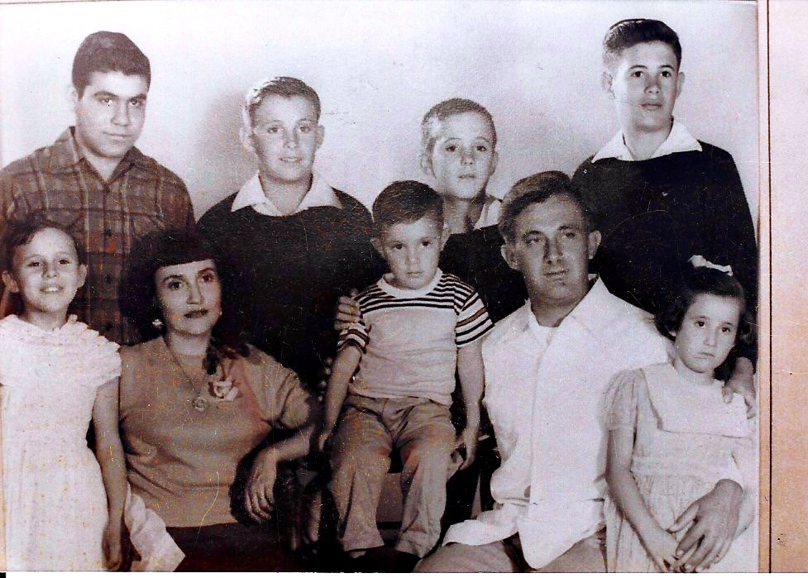

To do this I was getting $14 a week, enough to cover my needs, so in a way I was the Tijuana assistant correspondent of The San Diego Union and the San Diego Evening Tribune. During that time we used to go to San Diego’s downtown to collect our checks, but I was paid in cash. I remember going in the ferryboat to Coronado Island that no longer exists because they joined the island to Imperial Beach down south close to the border.

During that time my Uncle taught me about being generous with others that was the clear path to be in peace. Empathy was always his first reaction to any human conflict, he had a natural instinct to always look for the best in people. He was very generous with me during the following 20 years. Later on I realized that sometimes he was generous in the wrong direction, as to nourish his lower passions, women and alcohol addiction. Some of them, sometimes we nourished together. I learned that he had a tremendous love for the best there is, good or bad, and that you are free to choose, he never lectured me on religious grounds only that it is your morality that would make the choice to determine how bad or good you want to be. He balanced his life on those terms and to a degree I do too. Thank you Tio Rafael Mendivil Torres-Landa.

